**PF ASSIGNMENT – 10**

**QUESTION#1**

Write a recursive function that checks whether a number is a palindrome.

CODE:

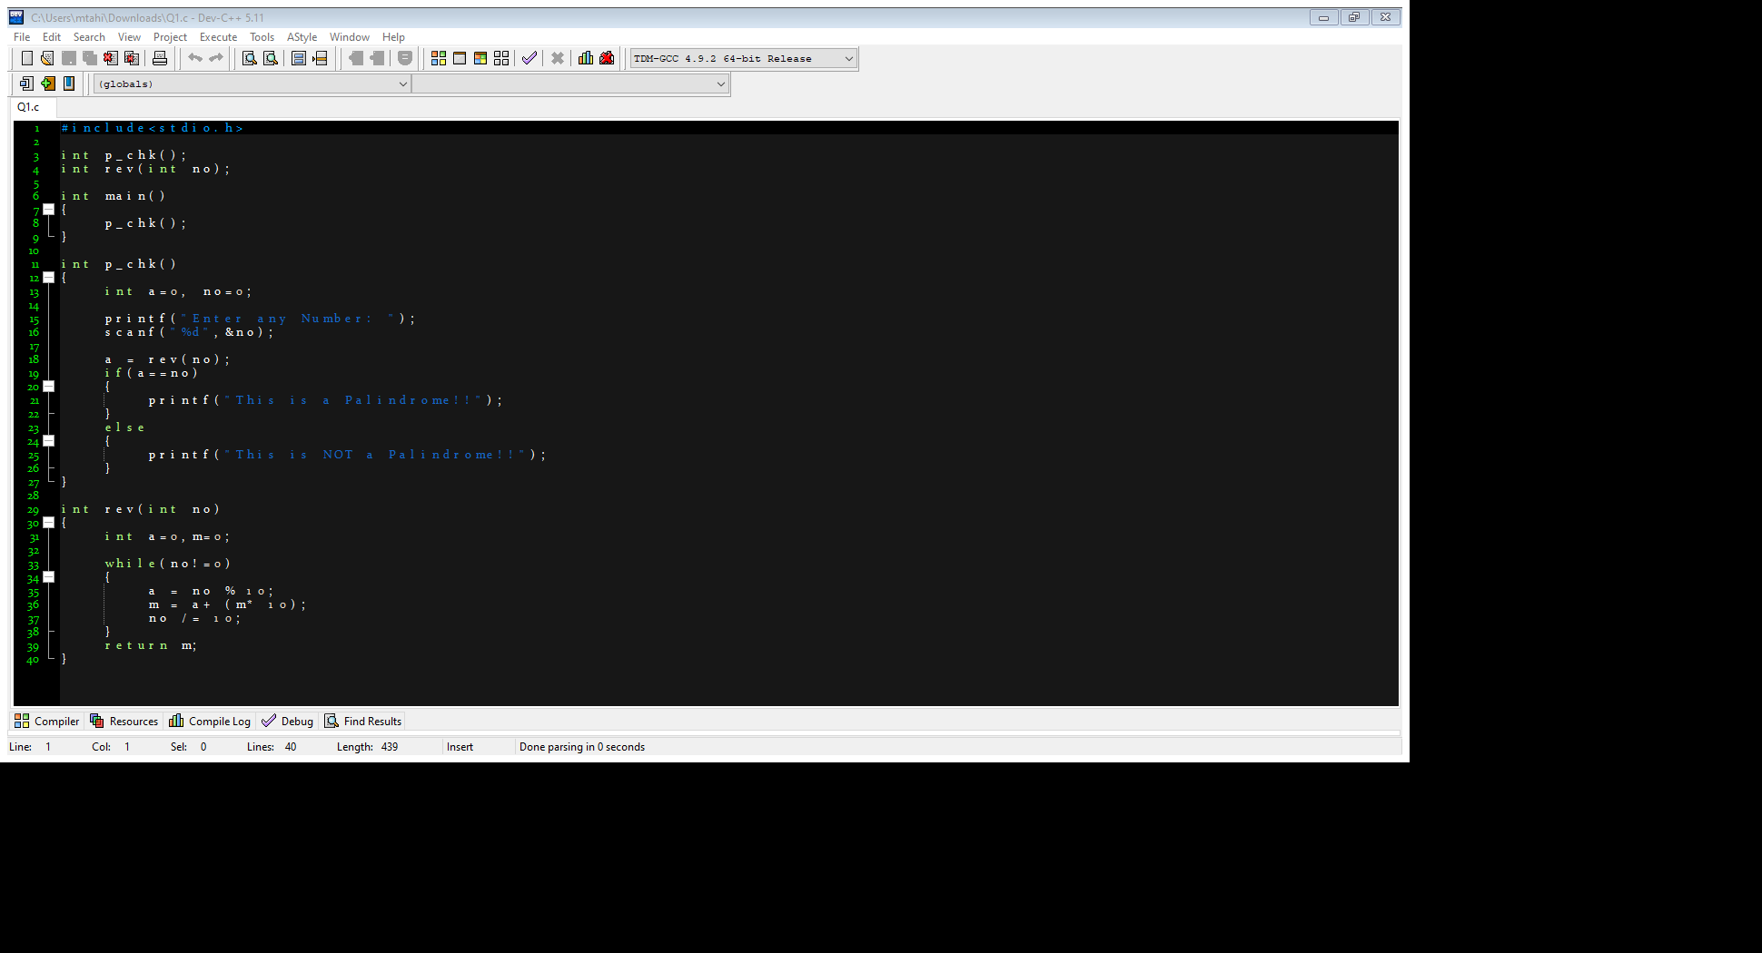

OUTPUT:

**QUESTION#2**

write a program to find the lcm of two numbers using recursion.

CODE:

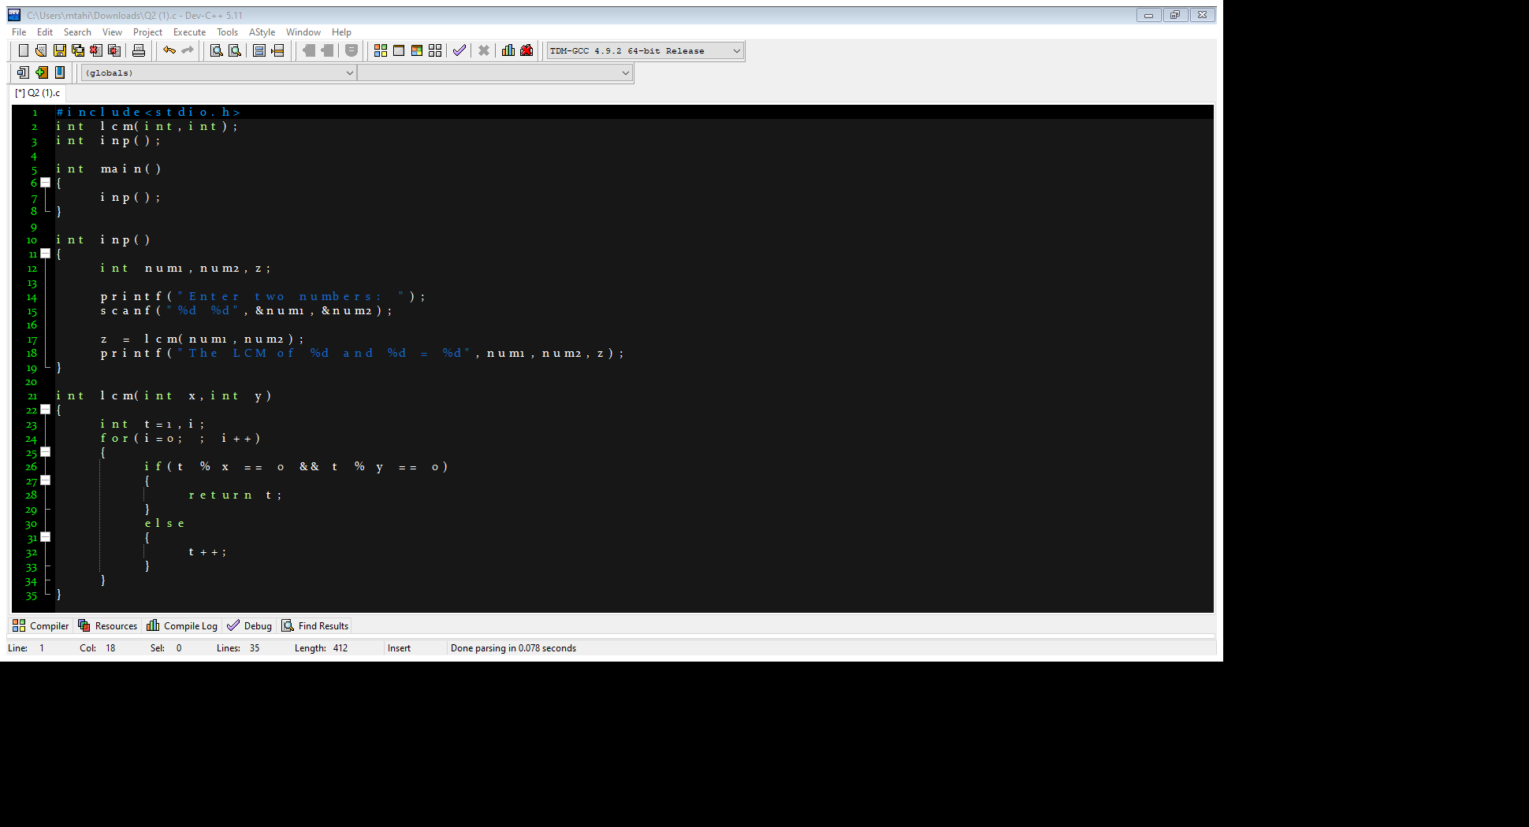

OUTPUT:

**QUESTION#3**

A phone number, such as (212) 767-8900, can be thought of as having three parts: e.g., the area code (212), the exchange (767), and the number (8900). Write a program that uses a structure to store these three parts of a phone number separately.

Call the structure phone. Create two structure variables of type phone. Initialize one, and have the user input a number for the other one. Then display both numbers. The interchange might look like this: Enter area code: 415

Enter exchange: 555

Enter number: 1212

Then display like below:

My number is (212) 767-8900

Your number is (415) 555-1212.

CODE:

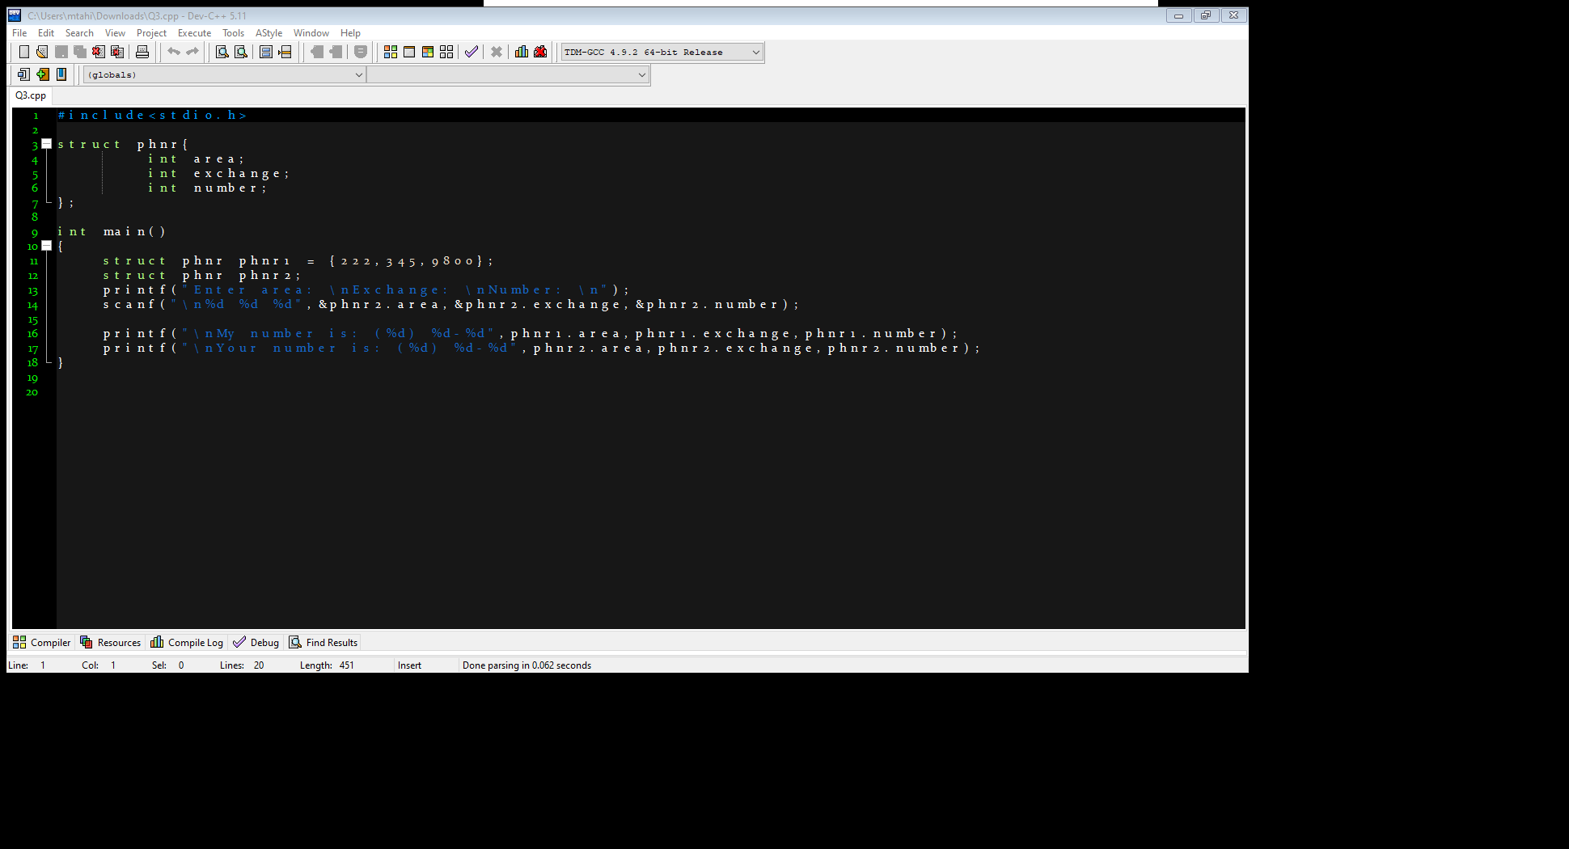

OUTPUT:

**QUESTION#4**

Write a C Program to Store Information of N Students Using Structure, where N is provided by the user. Student information should contain Student_id, stu_age, stu_name, street no, state, city, country.

CODE:

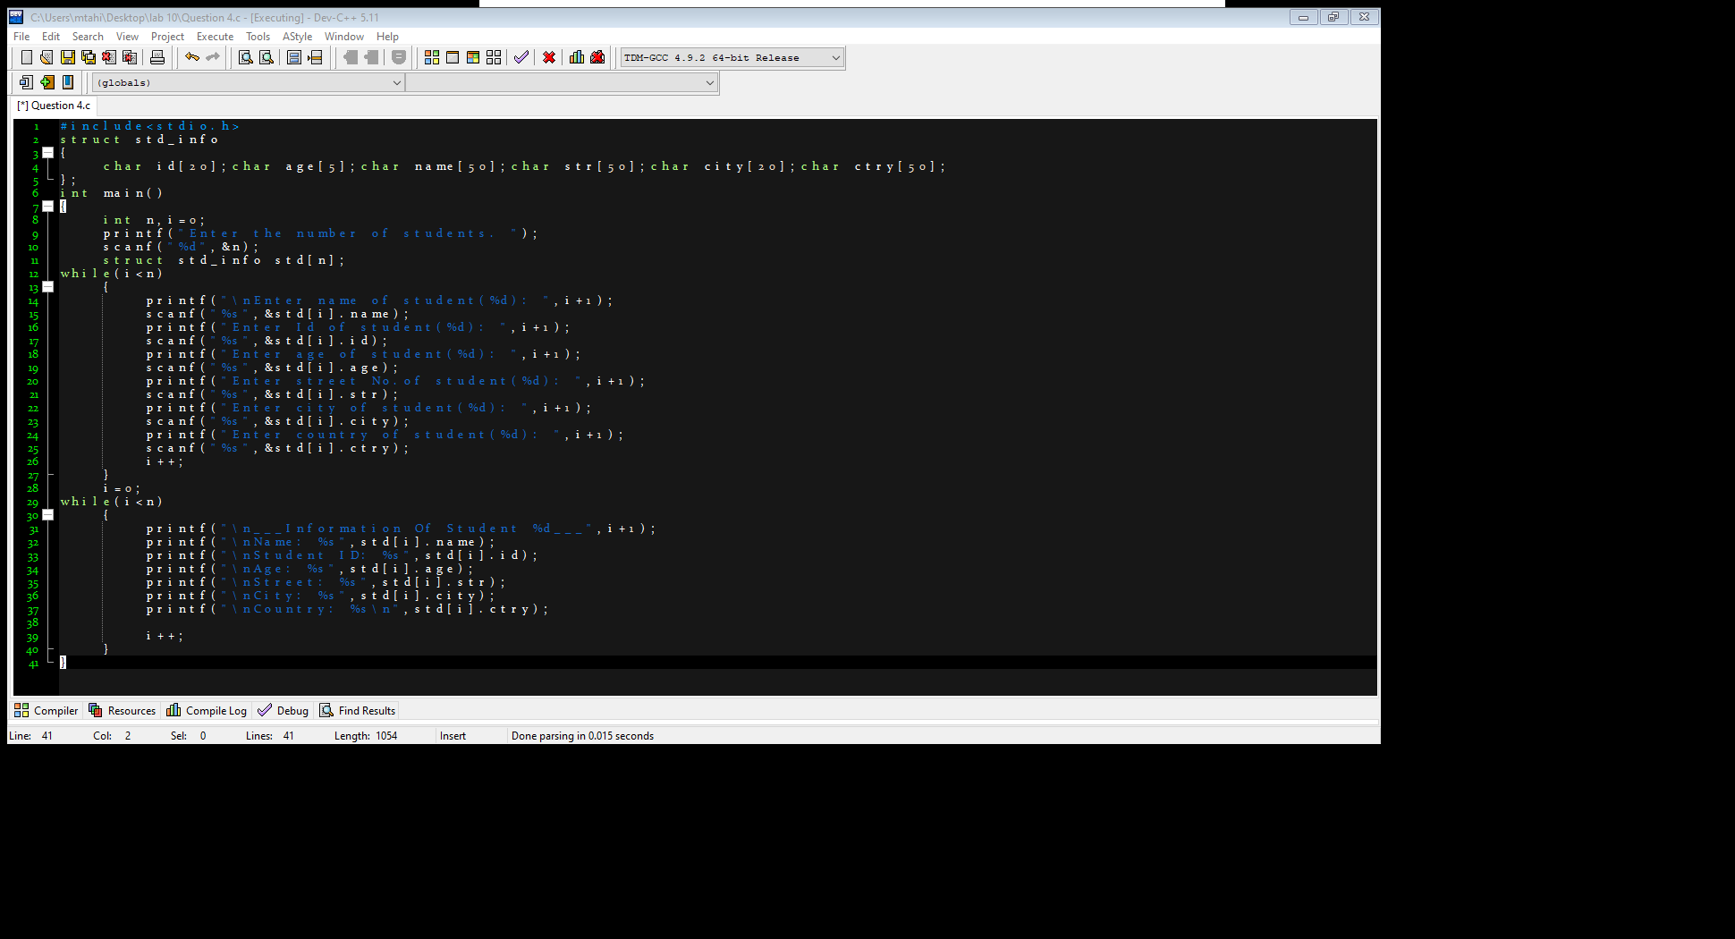

OUTPUT:

**QUESTION#5**

Write a C program that uses functions to perform the following operations:

i) Reading a complex number

ii) Writing a complex number

iii) Addition of two complex numbers

iv) Multiplication of two complex numbers

(Note: represent complex numbers using a structure.)

CODE:

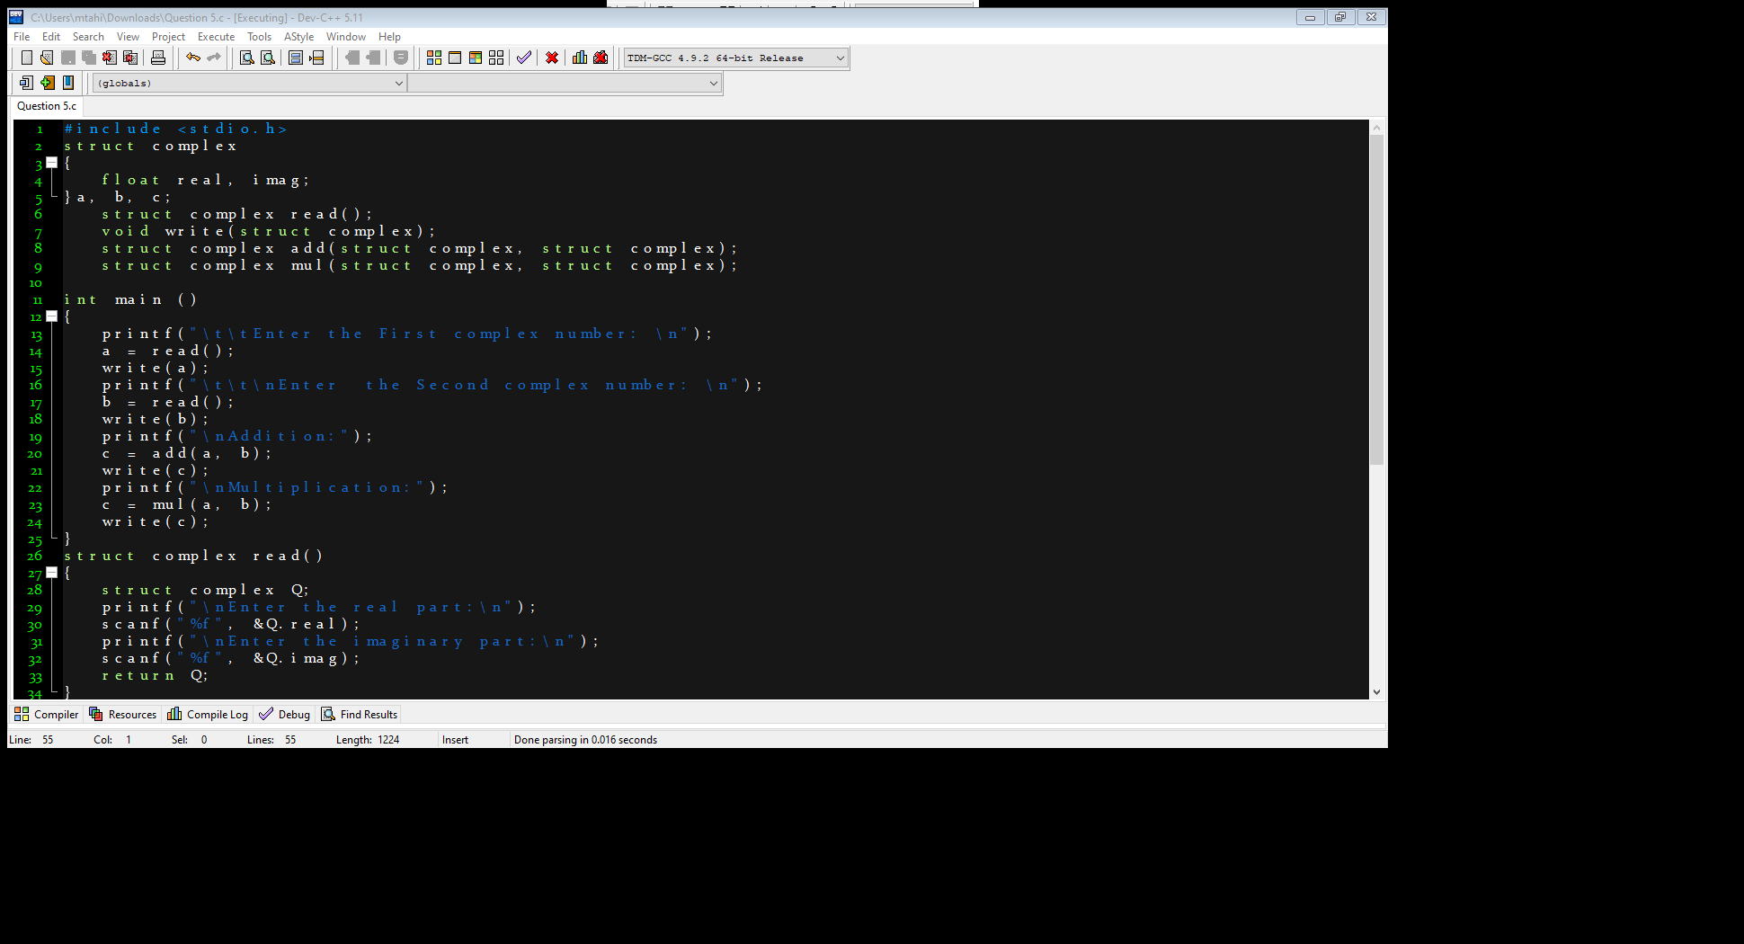

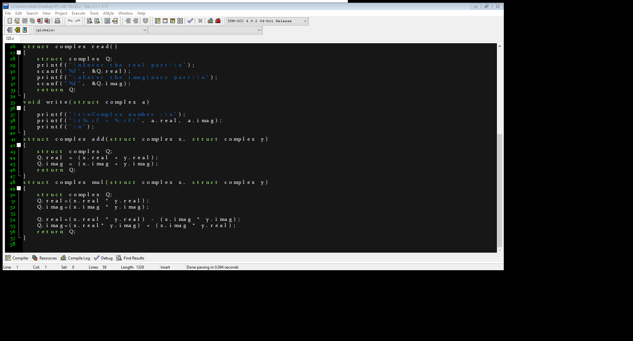

OUTPUT:

